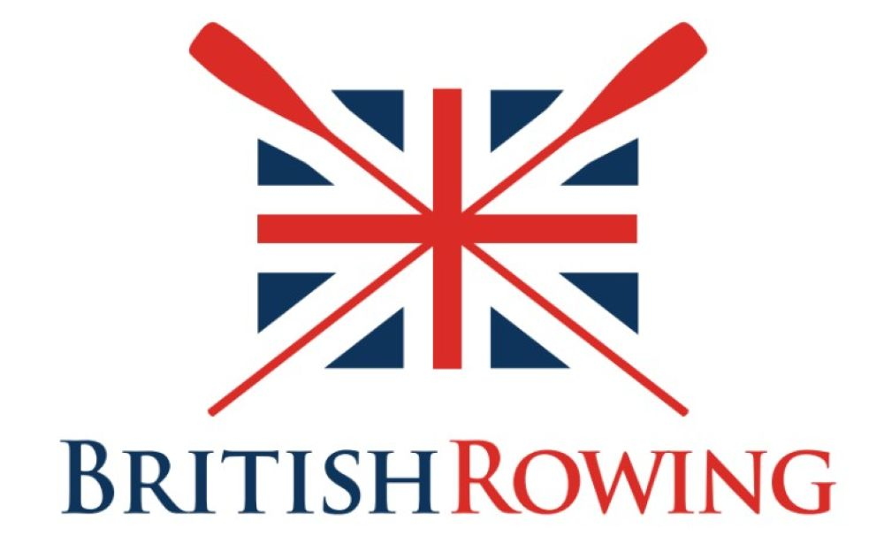

New Club Affiliation – Application Form

Club Name
Club Region
Club Type (Open, School, University/College or Alumni)

For school clubs
Partnership Agreement between the School and the Club: Roles and Responsibilities
If your school boat club is hosted on the premises of another boat / rowing club or organisation, we require a statement that clearly outlines the relationship between the school and the club/organisation, specifying the responsibilities of each party, particularly regarding on-the-water protocols. Please attach a copy of this document.

Additionally, the school may provide standard risk assessments (e.g., for transportation to the boathouse or procedures if a pupil goes missing) to define what the school is responsible for and what duties are handled by the club.
Committee Contact Details
To ensure an effective working relationship between your club, university/college or school and British Rowing, we need your key club contacts and/or relevant staff to have a profile on our ClubHub administration system. Please attach a document containing the contact details for the following roles:

1. CLUB CHAIR (can be Director of Sport or Head of Rowing) – for contact about any key club affairs

2. SECRETARY – for contact about key updates with your club details.

3. CLUB WELFARE OFFICER/HEAD OF PASTORAL CARE – for contact about key welfare, safeguarding updates or issues.

4. CLUB SAFETY ADVISER – for contact about any key safety updates or issues.

Clubs can also provide contacts for a Club Captain, Treasurer and Entries Secretary if you have these. If your club has more club committee members, the others can link themselves to your club on the ClubHub system once the club has been set up by British Rowing.

We will use this information to create free profiles, for anyone who does not already have one. Please note:

- This information will only be used for internal club profile management and will not be published publicly.
- Once we create the accounts, they'll receive a verification email to confirm their access.
- To support good club governance and avoid conflicts of interest your Club Chair and Club Welfare Officer should not be the same person or residing at the same address.

Secondary contact for payments
Please provide the contact email address for the club treasurer, finance department or bursar’s office and address for billing if this is different to the main correspondence or boathouse address.

Billing/Finance email

Billing/Finance address

Host Club Status
We ask for host club details to ensure we have current information on your club's location and host arrangements, which is vital for governance, safety, and support.
Is your club hosted on the premises of another boat/rowing club or organisation?
☐ Yes
☐ No
Host Club Details
You have indicated that your club is hosted on the premises of another rowing club or organisation. Please attach a document indicating that you have permission from your host club to carry out rowing activity. This letter should include:
- Name and address of Host Club
- Confirmation from the authorised individual granted to give this permission.
- Confirmation from the authorised individual stating the above-named Club has been granted permission to carry out rowing activity at their site.

Signed by
- Name:
- Position within Club (i.e. Chair / Captain):
- Signature:
- Date:
- Email:
- Phone:

Physical signatures required on this document.
General Club Information

Year Club Was Established
Physical Boathouse Address
Please provide the full address of the location where your boats are primarily stored or where the club operates.
Correspondence Address
Please provide the primary address for club correspondence. If this is the same as the Boathouse address, please enter "Same as above".
General Club Email Address
This should be the official club email address (e.g., secretary@clubname.co.uk).
General Club Phone Number
Please provide a main contact number for the club (e.g., 01234 567890).
Club Website URL

As a condition of affiliation this information will be published on British Rowing’s Club Finder and/or in the British Rowing Almanack to help support your club’s profile as part of affiliation.

If your club has a public presence on social media, you will be able to add the links on your club profile page in ClubHub. These will be visible on the British Rowing online club finder.
Membership Demographics
Your club's affiliation fee to British Rowing is based on the number of members in the club.
We are asking clubs to break down their total membership numbers by adult males, adult females, junior males and junior females to give us an idea of club demographics.
Please provide the total number of members in each category. You should declare every person holding membership of the club in any category, both British Rowing registered and non-British Rowing registered members.

If your club has any members with a long-term health condition or disability, please enter the number of those members in the space provided. This information will help us identify clubs that may benefit from support from our Adaptive Working Group.

Category | Number of Members
Number of Junior Female Members (Under 18)
Number of Junior Male Members (Under 18)
Number of Adult Male Members
Number of Adult Female Members
How many members have disability or long-term health conditions

Governance, Insurance and Safety

All clubs must hold adequate public/civil liability insurance and have an acceptable constitution.

Please ensure your constitution includes the required clauses (Equal opportunities, Safeguarding and Protecting Children and RowSafe compliance), examples of which are included in the model constitution.

If you are using Affiliation Plus, you need to provide your Employer Reference Number (ERN)/PAYE number (if applicable).
Club Constitution
Your club constitution should outline and guide how your club operates, be clear for your club committee and members and are suitable for your club type. How club members behave reflects on the club and on the sport in general so it’s important to set out the standards of behaviour expected from members.

Please note that a club will not be accepted for affiliation to British Rowing unless their Constitution contains an equal opportunities clause; confirms that the club will implement British Rowing’s policies on safeguarding and protecting children; and the safety requirements of the RowSafe Guide, examples of which are included in the model constitution.

You can download the British Rowing model constitution here. Please note there is a separate one for Clubs / Universities and Schools. We recommend keeping this in line with our model as applications for accreditation and funding will require certain clauses to be included and these are all contained in this document. Please attach your copy.
What is your club's formal legal structure?
We are requesting information on your club's formal legal structure to ensure our records for your club's governance are accurate and up to date.
Understanding your club's formal status is essential for administrative purposes, which is critical for liability, funding opportunities, and providing the most relevant support.

Please complete only the details that are relevant to your club.
☐ Limited Company
☐ Charitable Incorporated Organisation (CIO)
☐ Unincorporated Association
☐ Other
Registration/Company Number
Provide your registered company or charity number, and the jurisdiction of registration (e.g., UK, or relevant British Overseas Territory).
__________________________________________________
Institutional Status (For Schools/Universities)
If you are a school/university, does the club operate as an independent legal entity, or is it covered under the parent institution? If it operates under the institution, please confirm the registered name and number (e.g., company or charity number) of the parent body?
__________________________________________________
Insurance Status
All clubs must be insured. It is a requirement of all affiliated Clubs to have adequate and appropriate public and/or civil liability insurance in place to cover all the activities of the club, its committee and members. Please note standard Club Affiliation does not include club liability insurance.

Clubs need to ensure that all your activities are suitably protected by adequate liability insurance. We recommend clubs hold a minimum of £10m liability cover, if you want to take out insurance via the British Rowing Marsh Club Policy, please select Club Affiliation Plus.

For more information on club insurance and Affiliation Plus see the British Rowing Insurance site https://www.britishrowing.org/insurance/

☐ Yes, we are adequately insured
☐ We will purchase Club Affiliation Plus
If you tick “‘yes, we are adequately insured”, please attach a valid insurance liability policy summary (e.g., Public and Products Liability). Do not attach quotations, or expired copies.
Affiliation Plus & Employer Reference Number (ERN)
Clubs who take liability insurance via Club Affiliation Plus must provide us their ERN unless exempt - your ERN is also known as an employer PAYE number.

ERN/PAYE numbers usually come in the format: 123/A12345.

The collection of ERN data is required to populate the Employer Liability Tracing Office database which has been a part of insurance compliance since 2011.
Is your club exempt from having an Employer Reference Number (ERN)?
☐ Yes - If yes, please indicate reason:
☐ All employees are paid below the PAYE threshold
☐ No paid employees (volunteers only)
☐ No - Please provide your ERN (format: 123/A12345) ______________________________
Your club understands it is your responsibility to cancel any duplicate cover at point of renewal and British Rowing accepts no liability to offer a refund for any overspend on insurance for your club insurance if you fail to cancel your existing policy in time.
Please tick to confirm your club has checked the details of the British Rowing provided club insurance and that it meets your needs.
☐By taking Affiliation Plus, you agree to the British Rowing club insurance T&Cs.
Safety Audit
As part of the application process your club needs to complete the online British Rowing Safety Audit.
The audit consists of a number of sections including club details, equipment, safety management documents, first aid, incident reporting, training camps, and trailers. In addition to submitting an audit, clubs are required to upload relevant safety documentation, including their Club Safety Plan, to a secure Google Drive folder, which will be created for your club to help manage your documents. For any Club Rowing Safety Advisers (CRSAs) who are new or unfamiliar with Google Drive please get in touch as a guide has been created to help manage your documents.

All clubs need to complete the audit, so that British Rowing and your club can get confirmation that they are Hosting or Being Hosted and the Level of Host Cover, i.e.,
- the Host covers all Policies and the Safety Adviser
- the host provides the facility but the Policies and Safety Adviser are the Hosted Clubs

Please contact clubs@britishrowing.org when you are ready to do this so we can set your club up on the system and help you access your club Google Drive Folder.
Attach Safety Audit
The online audit must be submitted and approved by the relevant Regional Rowing Safety Advisor (RRSA) before your application can be considered complete. Once the audit has been approved, please attach a copy of this. Your application will then be ready for the final review and approval process.

Please contact your RRSA for advice or assistance with the audit.
Environment Agency (EA) Waterways

Is your club based on EA managed waterways? This map shows the EA waters in England where rowing takes place. Please complete the appropriate box below.

☐ Yes
☐ No
If you have answered ‘yes’, only complete these questions if your club owns its own craft. If your club is hosted and uses (borrows) equipment owned by the host club/organisation, you do not need to complete this section.

Boat Safety Scheme

EA based clubs are required to hold certification evidencing their compliance with the Boat Safety Scheme (BSS) for every motorised boat they own such as coaching launches. Please attach evidence of this with your application.

All boats requiring a BSS certificate have to be tested every 4 years so please check the expiry date of your certification to ensure this is still valid.
Insurance Details for Craft
Craft such as coaching launches and safety boats also need to be insured. The insurance must be valid for the full duration of the registration. The EA does not need a copy of the insurance certificate, but they may carry out sample checks on declarations.

As requested by the Environment Agency, please provide the name of the insurance provider, policy number and expiry date for your craft.
_________________________________________________________________________________________
_________________________________________________________________________________________
_________________________________________________________________________________________
Club Colours and Kit

British Rowing records the racing colours of every Club at the time of its affiliation.

Any subsequent changes to the racing colours or design shall not take effect until approved. Club colours will appear in the British Rowing Almanack and your blade design will be shown on Club Finder. The description of your blade and racing kit will be published in the annual Umpires Handbook.
Provide description of your club blade_____________________________________________________________
Provide description of your club kit________________________________________________________________
Please attach an image of your club blade and club kit. Any logo or emblem artwork must be supplied as a separate, flat version at a high resolution png., uncropped with a transparent background (and not applied to a blade shape). If you have editable .eps, (or ai, svg, ps) that would be useful.

Final Steps

Declaration
If affiliated, the below-named club has agreed to be bound by the British Rowing Affiliation Terms and Conditions and by the Rules and Regulations of British Rowing, as updated from time to time.
☐I understand and agree that the club affiliating supports the aims and objectives of British Rowing.
☐All activities will be conducted on an equitable basis and in accordance with the rules, policies, appropriate risk assessment and risk management procedures of the legal authority responsible for the club.
☐We understand that our club is responsible for keeping the provided contact details up to date on the British Rowing ClubHub system as one of the responsibilities of affiliation.

Date completed ______________________________________________________________________________
Form was completed by (name)______________________________________________________________

Email___________________________________________
Privacy Policy
We at British Rowing want to make sure all the personal information we have collected about you, is safe and secure whether we collect it through our websites or from other sources. This Policy set outs our commitments to you, in compliance with and beyond the General Data Protection Regulation (commonly known as the GDPR) and explains how we collect, store and use your personal information https://www.britishrowing.org/about-us/policies-guidance/privacy-policy-and-cookies-policy/
Checklist for attached items

- For school clubs - Partnership Agreement between the School and the Club
- Club committee details / key club contacts and or relevant staff
- Host club permission (if applicable)
- Club constitution
- Insurance evidence
- Safety audit
- Boat Safety Scheme certificates (if applicable)
- An image of your club kit and blade

