Epilepsy and Rowing - Appendix 2: Risk Assessment
The following table is a risk assessment template for a rower with epilepsy that provides some basic questions that should be considered. It allows for each risk to be considered and mitigation controls to be implemented to improve the safety of the rower and others in the boat.
- This table should be completed jointly by the club and the rower, and all risks and mitigation controls jointly assessed.
- The questions should not be considered totally inclusive, and both rower and club should add more depending on the individual circumstances.
- The risk assessment table should be regularly updated especially if the risks are considered to have changed.
- We recommend the club obtain consent to share this risk assessment with any competition organisers.
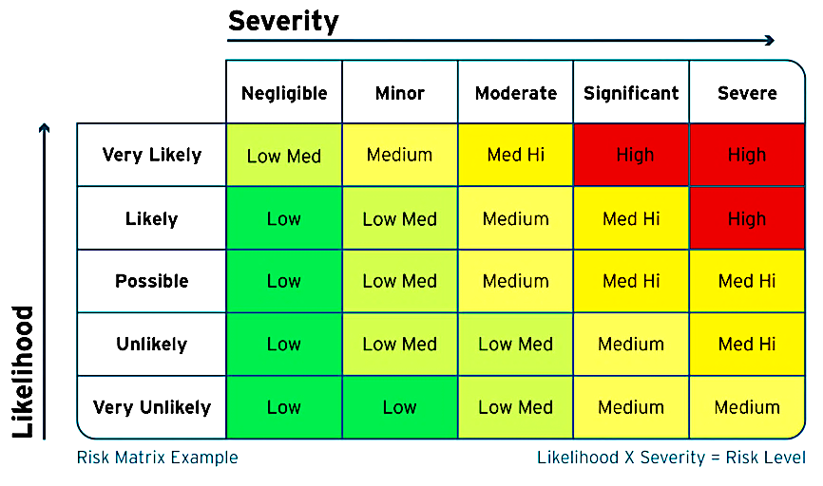
Key: [S] Severity; [L] Likelihood; [RR] Risk rating
Activity | Hazard | Who | Risk | S | L | RR | Controls | S | L | RR | Further action | Date
Rowing | Water | Rower who has a seizure | Falling in the water either in an unconscious or unaware state; lying in the bottom of boat in a similar state with the rower’s face in water; capsizing and becoming entrapped in an unconscious or unaware state
Rowing | Water | Rower who has a seizure | Water entering the lungs if the rower is in the water for any length time while having a seizure
Rowing | Boat | Rower who has a seizure | Head injury during a seizure
Rowing | Boat | Other rowers | Capsize or injury during an incident involving a boat under the control of someone who is having a seizure
[add more] | [add more] | [add more] | [add more]

