**Example Regatta Information for Clubs**

The competition is conducted under British Rowing Rules of Racing and RowSafe

**Regatta Control**

Regatta Control is situated in the green tent in the Regatta Field close to the Finish Umpires’ area.

**Timing**

**10:00** Refreshment Tent opens

**11:00** Safety Briefing for Club Captains, Umpires and Launch Drivers close to Regatta Control.

**12:00** First race starts

**17:40** Last Race starts

Crews are required to be at the start two minutes before their scheduled race time. Boating announcements will not be made.

Information for Competitors will be issued at the Safety Briefing.

#### Communications

#### There is very little mobile phone coverage in the vicinity of the lake. In an emergency contact Regatta Control. There is a landline telephone in the wooden building in the Regatta field by the lake, close to Regatta Control.

**Incident Procedure:**

Minor incidents on the lake will be dealt with by the Safety Boat drivers assisted by the Umpire’s boat drivers as appropriate.

Minor incidents on Land will be dealt with by Regatta Control assisted as appropriate.

First aid cover support will be provided at Regatta Control.

In the event of a major incident, outside assistance shall be coordinated by Regatta Control. See below for grid references for use by the emergency services.

Racing may be suspended or cancelled in the event of an incident.

**Abandonment Procedure**

If the organisers decide the conditions are unsafe or become unsafe they shall decide whether to use the alternative course or to abandon, or temporarily suspend the Regatta.

In the event of the Regatta being abandoned or suspended, announcements shall be made and all crews will come ashore.

**First Aid**

First Aid support is available from Regatta Control.

**Dogs**

Dogs must be kept on a lead and out of the water at all times.

**Emergency Services**

The Ambulance Service use Grid References to find casualties. The relevant locations near the Lake are:

Helicopter Landing Area SS 96530 30952

Boathouse SS 96694 30668

Rowing Pontoon SS 96829 30739

South West Lakes Building (with telephone) SS 96920 30886

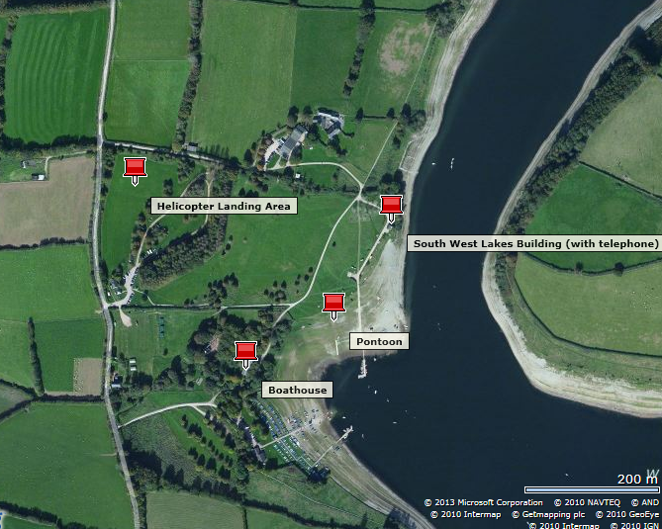

**Location**

The location of the Lake is shown on the plan below and directions to the Lake are provided in Appendix 1 of this Plan.. The postcode is TA22 9NU.

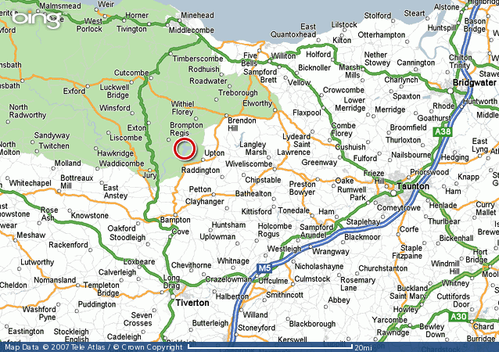

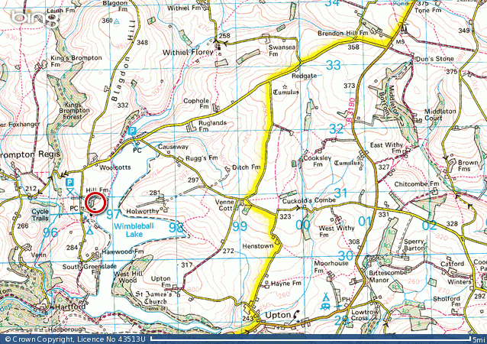

**Vehicle and trailer access routes**

Vehicles should enter the site by taking the first left turn from the lane as shown in the plan below:- 

They should then proceed to the Regatta field by following the track as shown in red in the plan below:-

**Parking**

Parking in not permitted on the areas of uncut grass.

**Boat Preparation area**

Boats should be rigged and de-rigged in the area shown above as for “Boats and Trailers only”.

Every Cox shall wear a lifejacket at all times when afloat.

#### Boat Safety

Crews **must not** get boated before being paired with competitors by Marshals. Random checks of safety equipment (e.g. heel straps, bow balls, hatch covers, etc) as well as coxes’ lifejackets will be carried out by a British Rowing Umpire or delegated officer as an audit check for safety conformance. It must be emphasised that it is the Clubs’ and master of the vessel’s responsibility – not that of the Regatta – to ensure that they row in equipment that conforms to RowSafe. The passing of a random check, for example on a bow ball, should not be interpreted as tacit approval or acceptance by the competition that the boat as a whole is safe.

**Boat Launching and Recovery**

Boats may be launched from and recovered to the edge of the Lake as shown in the above plan or from the white pontoon.

**Route to the start, and the course**



Crews proceeding to the start should be aware that the boat carrying the Umpire of each race will need to proceed at speed in order to keep up with the race and may thereby create a wash.

The line of buoys to the West of the course separates the route to the start from the course. The line of buoys to the east of the course separates the route that the Umpires boats will take from the finish to the start. **Any crews that cross either line during a race will endanger themselves and others and WILL BE DISQUALIFIED. Any crews on the way to the start who row onto the course and thereby endanger, hinder or otherwise inconvenience a crew in a race WILL ALSO BE DISQUALIFIED.**

Crews wishing to practise starts should do so in an otherwise empty part of the Lake away from the direct route to the start so as not to inconvenience other crews on their way to the start. Crews wishing to warm-up may do so in the area to the east of the start line and must not stop on the route to the start.

The area of the lake under and past the bridge is a Nature Reserve and no crew may enter this area.

The start line will be marked by two red buoys, the start umpire’s boat being located at one end of the start line as shown. All crews must come under starters’ orders 5 minutes before the published start time of the race (or five minutes before the first heat if the event has heats).

The start of the 500m course will be marked by two red buoys, this is also the mid point of the 1000 m course.

Lane 1 will be on the starboard side of the course. This is closest to the start Umpire’s boat and on the Regatta field side of the course.

The finish line is defined as the line between a post in the Regatta field and a flagpole on the far side of the lake. Two spherical red buoys will be located close to the finish line.

**Alternative course**

If weather conditions are such that the course becomes unsafe then the alternative course may be used. This is shown on the plan, above. Announcements will be made if this is necessary. The alternative course is about 700 metres long.

The start of the alternative course is at the east (far) end of the course and the finish is at the west end (the end nearest the Regatta Field). The route to the start will be to the south of the course. These routes may not be marked by buoys.

There are no special points of danger on or near either of the courses and no areas of shallow water other than at the edge of the Lake.

**Umpires – primary course**

The start Umpires shall be in the boat at the western end of the start line.

The mid-course Umpires will follow alternate races in motor boats.

The finish umpires will be located on the finish line in the Regatta field.

**Umpires – alternative course**

The start Umpires shall be located on the start line on the bank to the north (starboard side) of the alternative course.

The mid-course Umpires will follow alternate races in motor boats.

The finish umpires will be located on the finish line on the bank to the north (starboard side) of the alternative course.

**Safety Boats**

There shall be two safety boats located between the course and the route to the start.

**Appendix 1 - Directions to the Regatta**

**from Junction 23 of the M5 – Bridgwater**

|  |  |  |
| --- | --- | --- |
| 1. | Head **east** toward **A39** | 0.2 mi |
| 2. | Continue straight | 0.4 mi |
| 3. | At the roundabout, take the **1st** exit onto **A38/Bristol Rd**  Go through 1 roundabout | 2.3 mi |
| 4. | At the roundabout, take the **2nd** exit onto **A38/A39/Monmouth St**  Continue to follow A39  Go through 2 roundabouts | 3.7 mi |
| 5. | At the roundabout, take the **1st** exit and stay on **A39** | 0.7 mi |
| 6. | At the roundabout, take the **1st** exit and stay on **A39** | 13.4 mi |
| 7. | Turn **left** at **A39/Fore St** | 390 ft |
| 8. | At the roundabout, take the **2nd** exit onto **A39/Bank St**  Continue to follow A39 | 1.2 mi |
| 9. | Turn **left** at **B3190** | 3.0 mi |
| 10. | Turn **right** to stay on **B3190** | 1.5 mi |
| 11. | Continue onto **B3224** | 0.7 mi |
| 12. | Continue onto **B3190** | 1.2 mi |
| 13. | Turn **right** | 3.3 mi |
| 14. | Turn **left** at **Bryant's Hill** | 0.3 mi |
| 15. | Turn **left** | 0. |

**from Junction 25 of the M5 – Taunton**

|  |  |  |
| --- | --- | --- |
| 1. | Leave the Motorway at **Exit 25** | 0.2 mi |
| 2. | At the roundabout, take the exit onto **A358** heading to **B3227/A38/Taunton/Minehead/Wiveliscombe**  Go through 1 roundabout | 1.5 mi |
| 3. | At the roundabout, take the **3rd** exit onto **A358/Obridge Viaduct**  Continue to follow A358  Go through 1 roundabout | 1.2 mi |
| 4. | Slight **right** at **A358/Greenway Rd**  Continue to follow A358  Go through 1 roundabout | 1.5 mi |
| 5. | At the roundabout, take the **2nd** exit and stay on **A358**  Go through 1 roundabout | 3.9 mi |
| 6. | Turn **left** at **B3224** | 9.7 mi |
| 7. | Continue on **B3190** | 1.2 mi |
| 8. | Turn **right** | 3.3 mi |
| 9. | Turn **left** at **Bryant's Hill** | 0.3 mi |
| 10. | Turn **left** | 0.1 mi |

**Appendix 2 - Boat Checks**

|  |  |
| --- | --- |
| Clubs should check the following before travelling to the Regatta |  |

Boat Checks (taken from RowSafe section 7.1 Boats and Blades)

**check that:-**

* buoyancy compartments,
* seals,
* hatch covers,
* boat hull and
* ventilation bungs

are secure and watertight.

**check that:-**

* the bow ball is securely fixed and fully covers the bow of the boat in order that adequate protection is given to any person or object struck by the moving boat and
* that any fixing screws or do not represent a further hazard in the event of accident.

**check that:-**

* outriggers,
* swivels,
* gates,
* seats and
* stretchers

are secure and operating freely.

* In difficult water conditions check that ‘splash boards’ available and fitted?

**check that:-**

* heel restraints are secure and
* that restraints are adequate and effective.

(Heels should be positively restrained not to rise higher than the lowest fixed point of the shoe.)

**check that:-**

* rudder lines,
* steering mechanisms,
* rudder and
* fin,

are secure and in good working order.

**check that:-**

* oars and sculls are not damaged and
* ensure that ‘buttons’ are secure and properly set.

**check that:-**

* the boat is suitable for the situation in which it is to be used, for example maximum crew weight.