Thank you very much for your interest in applying for this role. Here is a message from Matt Rostron, CEO of London Youth Rowing:

“London Youth Rowing has achieved a great deal since it was formed and launched in 2005. It has worked with hundreds of schools and partner organisations, received a huge amount of financial and operational support over the years, ran exciting National events and attracted support of organisations like us from around the world and had an impact on the lives of many thousands of young people too. All of that has only been possible by the amazing, inspirational, and talented coaching staff that we have been incredibly lucky to employ and work with since we started over 15 years ago. This is an incredible opportunity to join that team at a very exciting time for the organisation and work with fantastic schools and teachers and have a positive impact on the physical and mental well-being of young people across London and in other parts of the UK too.”

This job information pack is designed to give you an insight into LYR, our work, and the role we are recruiting for. Included in the pack is:
- an introduction to LYR
- a job description
- a person specification
- guide to applying for the job

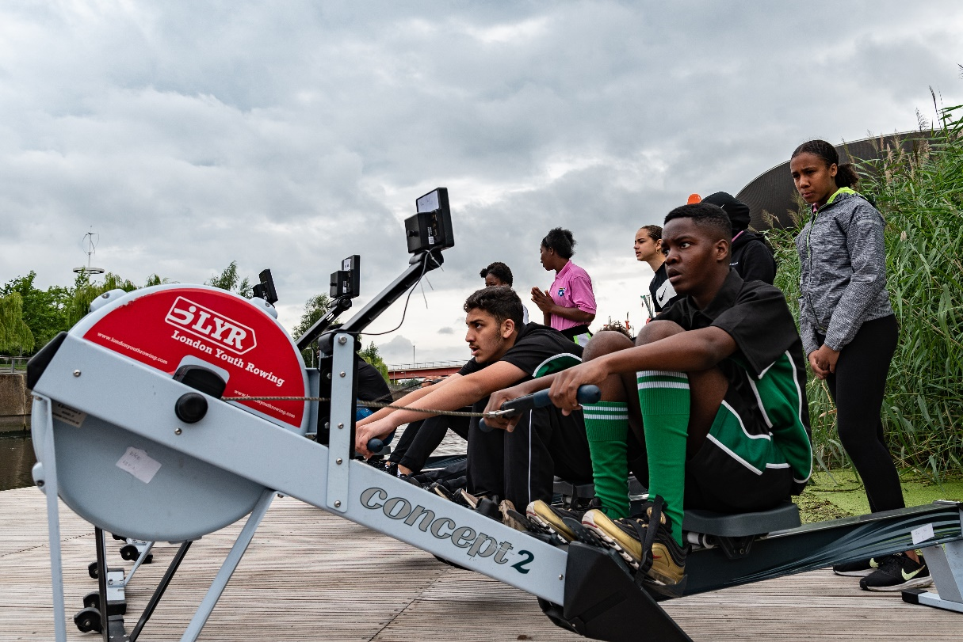
  - Introduction
Who are we?
London Youth Rowing (LYR) was founded in 2005 and is based in East London. LYR believes in sport, specifically rowing, for social change and uses rowing to empower young people to aspire, believe and achieve. We work with schools and communities across London and in 2021 will be launching our first major programme outside London, in Leeds. We have a team of 15 full time employees, combining our coaching team and office staff.
You can find out more about LYR on our website: https://www.londonyouthrowing.com/
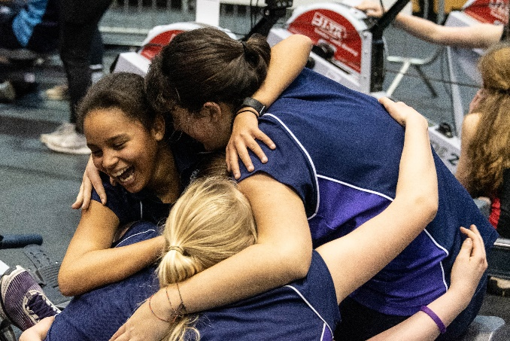
What do we do?
LYR’s impact and scope is wide and varied. We provide opportunities for young people from disadvantaged areas to experience the benefits of rowing through our range of coaching, inclusion and health programmes. LYR creates opportunities and an environment for young people to fulfil their potential and experience success. You can find out more in the latest LYR Annual Review.
What are you applying for?
You will find in this pack a job description for the role we are recruiting for along with the person specification which highlights the specific skills, qualifications and experience required for the job.
Equality Statement
London Youth Rowing recognises the positive value of diversity, promotes equality and challenges discrimination. We particularly encourage applications from disabled candidates, female candidates and candidates from ethnic minorities, as we work extensively with young people from these backgrounds and these groups are underrepresented in sports organisations and the charity sector.
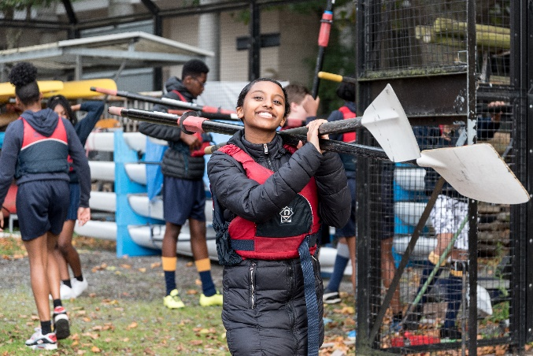
Safeguarding Statement
LYR uses sport to engage & inspire young individuals to achieve their potential. Protecting children and adults at risk from harm and promoting their wellbeing is fundamental to achieving this mission. All successful applicants will be required to complete a DBS check before starting their new role – as per the NSPCC safer recruitment guidelines.

  - Responsible to:

  - Emily Coe, Programme Director

  - Role Purpose
As part of LYR’s coaching team, you will be working within a team of coaches that manage a network of schools and organisations across London. You will be responsible for managing the relationship that LYR have with a number of those schools and organisations at every level. Working with participants from a range of different backgrounds, you will be introducing them to the sport of rowing and encouraging them to get involved in physical activity. The sessions are run within both the schools and organisations but will also include sessions on water. You will often be working independently and remotely but need to maintain good, strong communication with your coaching team and support your colleagues closely both mentally and practically
Scope:
London Youth Rowing delivers programmes across London, and each coach will be required to help with events in different areas. Primarily they will lead on the development of one recreational ‘Rowing Open Club’ in particular and will work with Secondary Schools in London. During School holidays, the Community Coaches deliver ‘Learn to Row’ courses at different locations and sites across Greater London.
  - Pay and Working Hours
This is a Full Time position with a salary in the range of £22, 000 - £24,000 per annum based on experience. The working hours are Monday to Friday, typically 0900-1700 or equivalent to be agreed with your line manager. Days in lieu of working additional hours must be arranged and agreed with your managers. You will typically be required to work remotely, daily based at one of our partner schools or from the LYR Head Office (Royal Docks Adventure, Newham, E16 2QT), you should be able to work remotely if required.
Responsibilities:
- To build participation in our partner schools and participants to pre-determined and agreed goals and targets
- To deliver engaging indoor rowing sessions to new and existing participants, building participation
- To confidently lead ‘On the water’ rowing sessions for schools and learn to row courses. LYR can provide training for development and qualification needed.
- To support and work alongside other LYR Staff in producing resources and videos to support schools and other organisations that LYR may work with.
- Delivery of high quality coaching and good engagement with young people who may be at risk of dropping out of sport and physical activity
- To develop strong relationships with each Partner School, specifically PE Teachers, Heads of Department and the Senior Management Team in Partner Schools
- Collection of weekly data and regular surveys of young people within set timeframe to ensure impact measurement
- To work with other LYR Coaches to deliver taster sessions and local and Area Indoor Rowing Competitions
- To ensure Indoor Rowing Clubs maximise the social experience and cater for changing motivations of young people
- To work with our LYR staff to identify case studies and new content for social media and promotion
- To promote the pathway from the Indoor Rowing Clubs (School based) to a Open Club, LYR Club or onwards to a different sport if appropriate
- To ensure each Partner School prepares young people to enter the LYR National Junior Indoor Rowing Championships to pre-determined and agreed goals and targets
- To attend the latest training and qualifications to keep up to date with Coaching experience
- To maintain records for internal reporting purposes and other ad hoc administrative tasks as required by Management
- To work with the LYR team to facilitate key events throughout the year
- To present a positive image of London Youth Rowing and partners at all times
- To represent the core values of London Youth Rowing

Essential Criteria
Experience of working with young people and Schools of Secondary age
Coaching experience – 11 to 18 year olds in different sports and activities
Experience creating and developing an inclusive environment where all young people can take part
Excellent verbal, written communication and IT skills
Ability to work remotely and self-motivated
*UKCC Level 2 Certificate in Coaching Rowing or relevant experience in coaching rowing, with confidence around the water
*The UKCC Level 2 Certificate in Coaching Rowing is not a requirement to apply, but the successful applicant will be required to complete the course within the first 6 months of their start date.
Desirable Criteria
Qualifications:
Full UK Driving Licence
RYA Power Boating Level 2 Certificate
Safeguarding & Protecting Young People Course
This role is subject to an Enhanced DBS check (previously a CRB check).
  - How to Apply
In order to apply for this role, you should submit:
- An updated CV which shows your full career history with any breaks explained, we recommend that this is no longer than three pages;
- A supporting statement explaining why you are interested in this role, detailing how you are a good candidate for this role and how you fulfil the person specification, again we recommend that this is no longer than two pages;
Please submit the documents via email to:
Emily Coe, ecoe@londonyouthrowing.com

If you apply, we will aim to acknowledge your application within 24 hours of receipt. If after that time you have not heard from us, please telephone the LYR office (0203 434 0990) to ensure that it has arrived. Using a secure email address and putting the job title/organisation in the subject line reduces the chances of any email going into spam.

  - More Information
Thank you for taking the time to read this job information pack, we hope that you have found it useful. If you are interested in applying and have questions about the role you would like to ask first, please send an email to info@londonyouthrowing.com with the job title/organisation in the subject line and we will get back to you.
