COMPETITOR HANDBOOK

27 & 28 June 2020

WELCOME

Welcome to the inaugural British Rowing Virtual Championships. The Organising Committee look forward to welcoming you to take part in this exciting new event on Saturday 27 and Sunday 28 June.

With over 800 competitors, from 30 different countries, and more than 1200 race entries, the British Rowing Virtual Championships is shaping up to be an exciting weekend of real-time, side-by-side racing.

Please read through this Competitor Handbook so you know how the weekend will run. We will have volunteers on hand throughout the weekend should you need to contact us, and they will be happy to help answer any questions.

We look forward to seeing you at #BRVC20.

Daniela Mingham
BRVC20 Event Director

IN ASSOCIATION WITH

MEDICAL GUIDANCE UPDATE - CRITICAL TO READ

Please read the following guidance carefully before taking part in the British Rowing Virtual Championships. In the event you need to make a change to your entry, or cancel it, please contact British Rowing at: virtualchamps@britishrowing.org.

1. PARTICIPATION IN THIS EVENT IS ENTIRELY AT YOUR OWN RISK:
Should you feel that you are no longer able to compete in the British Rowing Virtual Championships, you can withdraw your entry by emailing virtualchamps@britishrowing.org in line with the published terms and conditions.

2. COMPETING ALONE: We strongly recommend you do not compete alone. At the very minimum, alert someone of your race start time and check-in with them when you finish.

3. MEDICAL ISSUES DURING RACING: If you experience any pain, discomfort, nausea, dizziness, or shortness of breath while participating in this event, please STOP rowing and consult a medical expert.

4. JUNIORS: If you are under 18 years of age, you must have a parent or legal guardian on site with you. If you are the parent or legal guardian of a competitor under the age of 18, you agree to be fully responsible for their safety.

5. COVID-19: If you have
a. tested positive for Covid-19, or
b. had symptoms of Covid-19 but a negative test, or
c. had suspected Covid-19 without a test
you should seriously consider whether you are fit and healthy to race. We strongly advise anyone who has had Covid-19 or symptoms, not to race.

6. BE PREPARED: Please make sure you warm up properly, have eaten and hydrated sufficiently, you are wearing appropriate clothing and footwear and the location of your rowing machine is cool and well ventilated. Ensure you have practised your race distance or time before the event; the race should not be the first time you attempt it.

If you stop rowing during your race for any reason and are unable to continue with the race, please email officials@britishrowing.org ASAP to confirm your situation.

GETTING SET UP
In advance of the race
Here is a link to the Homerace manual which you may find useful when setting your machine up and connecting it to your computer. It includes troubleshooting advice and tips for minimising connectivity issues. We recommend that you run through this procedure in advance of race day to confirm you are able to access the race system.

In order to take part in the event you will need to ensure your Concept2 monitor (PM3/4/5) has the most up to date FIRMWARE. You can check this by downloading the Concept2 Utility software and following the instructions. This process should only take a few minutes but we recommend that you do this in advance of race day.

In this email you will have received your ‘participant secret’ which is the race link for each of your events. Each link will be unique to you, and to the event you are competing in e.g. separate links for 2km, 500m, relay events. These links will take you through to the race lobby for each event. Please arrive in the lobby 40 minutes prior to your race start time.

Competitor timeline

- 40 minutes prior to race start – enter the race lobby via your ‘participant secret’

- Up to 30 minutes prior to race start – deadline for lightweight weigh-in (see below for procedure)

- 5 minutes prior to race start – race lobby locked for entry, no further admittance allowed*

- 2 minutes prior to race start – competitors must be in position and ready to race

- 1 minute prior to race start – stop rowing, put your handle down and watch your monitor and/or computer screen for race start instructions

*if you miss your race, you may be added to the ‘Better late than never’ race at the end of the day by emailing officials@britishrowing.org. Competitors who race in this event will not be eligible:

- To progress to a final (in the case of heats) or;
- To be awarded a medal (in the case of straight finals)

Whilst in the race lobby you may continue to use your machine to warm up at any point until you are directed to stop rowing through a message that will appear on your computer screen. During this time your rowing machine monitor may change screens a number of times – this is normal and you do not need to do anything whilst this is happening.

A race official will be monitoring the race lobby for each event, and any updates from them will come through the lobby. These messages will be visible on your computer screen.

Race start procedure
The race start procedure is the same as at the British Rowing Indoor Championships. You will be given a warning two minutes before the race is due to start. With one minute to go you will need to stop rowing and put your handle down to allow the rowing machine fan to stop. You will then be instructed to pick up your handle and get ready to race. All race start instructions will be visible on your rowing machine monitor.

You can find further details of, and familiarise yourself with, the race start procedure and race view below:

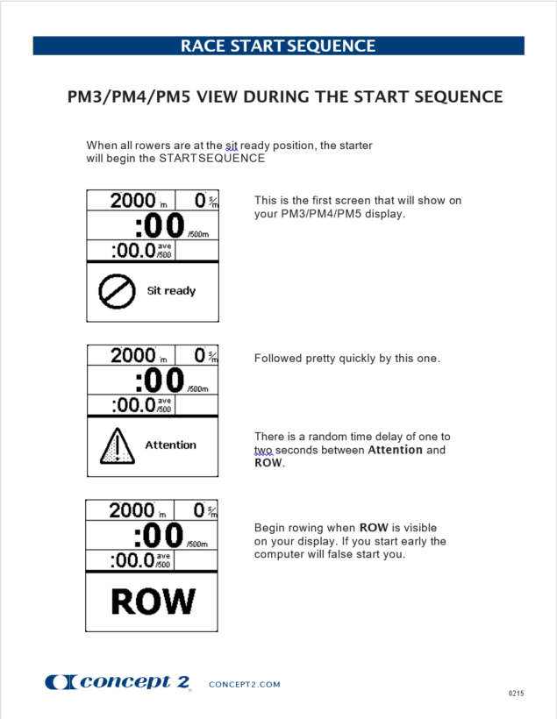

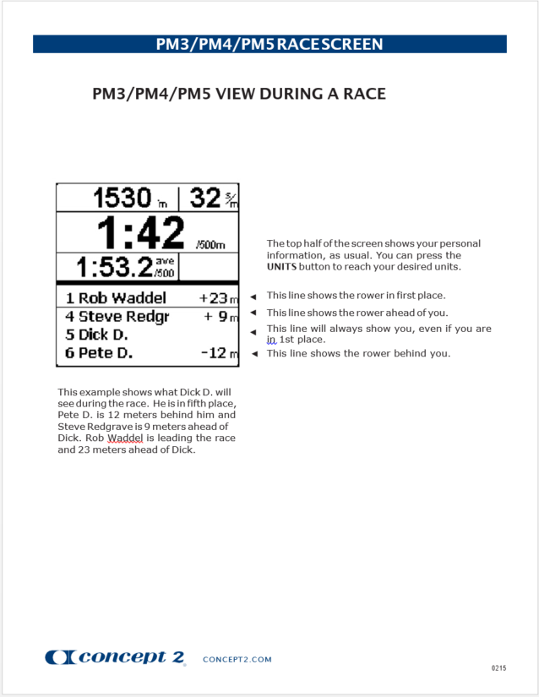

During the race
If you experience technical issues during your race, please continue to row until you have completed the distance. If the connection comes back in this time the race system will be able to read your back up file and extrapolate your score. If it does not come back, your monitor will still contain your score which can be manually added after the race.

You will need to go to the Memory, List by Date and select the workout corresponding to your race. Press the 4th button twice to display an authentication code. Take a photo of that and send it through to officials@britishrowing.org and we will ensure the data is manually added.

After the race
Once the race has finished, the race official will approve the race at which point the race system will disconnect your monitor. You do not need to do anything whilst this is happening, but please do not disconnect your monitor from your computer until the rowing machine monitor has returned to the normal view.

Lightweight Weigh-In
Rowers entered in a lightweight event are required to ‘weigh-in’ from two hours before the start of the racing day (i.e. 07:30 on Saturday and 08:00 on Sunday) and no later than 30 minutes prior to the start of their race. Photo evidence of the competitor’s weight must be submitted by email to lwts@britishrowing.org. For more information, please refer to points 32-34 of the Terms and Conditions of entry.

Photo evidence needs to show you on the scales in your racing clothes with the reading visible along with a date (this could be by including a newspaper or the home screen of a phone showing the date) on the date of competition.

If a competitor does not make weight or they miss the cut-off time for weigh-in, they will still be able to race, however they will not be eligible to win a medal.

Adaptive entrants
Due to the inability to hold classification on the weekend of the event, we request that all those entered in adaptive events submit whatever classification documents they may have from their respective national federations to classification@britishrowing.org for approval.

This does not apply to those in the AR3-Open category who should instead email the above to request a self-declaration form as per points 26 and 27 of the Terms and Conditions.

Relay teams
Adult relay: 4 x 1km.
- All team members will row at the same time over 1km.
- The average split time will be calculated in real time from all four teammates to give a team result over 1km.

Junior relay: 4 x 2 minute.
- All team members will row at the same time over 2 minutes.
- The average distance covered from all four teammates will be calculated in real time to give a team result over 2 minutes.

Para/Adaptive relay: 4 x 2 minute.
- All team members will row at the same time over 2 minutes.
- The average distance covered from all four teammates will be calculated in real time to give a team result over 2 minutes.

Each team member will receive their own unique link to log in to the race system for the relay race, and the system will group you according to entries - you do not need to do any calculations yourself.

Results
Results will be provisional on completion of the race and will be made available on the British Rowing website. Once results of each race are made official our results page will be updated to reflect this.

Sports Presentation
Every race across the weekend will be streamed live on the British Rowing website - https://www.britishrowing.org/brvc - with live commentary and we would like to encourage as many spectators as possible. Some invitational races taking part on Sunday will also have live webcams where spectators can view the competitors as they race.

Medals/winners
Medals will be awarded to winners only. In the event of Heats and Finals, medals will be awarded to the winner of the A final only. We will be in touch following the event to arrange postage of the medals.

Records
The British Rowing Virtual Championships has been confirmed as a Concept2 sanctioned event, and therefore Concept2 records can be broken by competitors – with the exception of lightweight records due to the inability to verify weigh-in procedures appropriately. See the Concept2 website for more information on how this would normally be verified.

British Rowing will be in touch following the British Rowing Virtual Championships with any competitor who appears to have broken a record during the event to confirm the process of verification but for those who think it is a possibility, please bear the following in mind:

In order to approve a record, Concept2 require you to submit a video of the row. This video needs to be a single take that includes a close-up of the monitor before the start, a clear view of the athlete and erg throughout the race, and a close-up of the monitor after the finish.

The ErgRace log file will need to be submitted to Concept2 by the race organiser, which in this case is British Rowing.

Documentation to confirm age is to be made available upon request along with proof of sport class from an international (World Rowing) or a national governing body for para-rowing.

Clean Sport
The British Rowing Virtual Championships (BRVC) is committed to clean sport and believes every rower has a right to take part in the BRVC knowing they and other competitors are competing clean. All athletes and athlete support personnel who take part in the BRVC must abide by the World Anti-Doping Agency Code, and British Rowing Anti-Doping Rules which are the UK Anti-Doping Rules. All participants are encouraged to report any information, or suspicions concerning a competitor in breach of the Anti-Doping Rules. To understand more about anti-doping, the rules, your responsibilities, and how to report doping please visit https://www.britishrowing.org/about-us/governance/anti-doping.

If you have any questions before the event, email antidoping@britishrowing.org.

FURTHER INFORMATION

On-the-day contact
General event enquiries: virtualchamps@britishrowing.org
Racing specific enquiries: officials@britishrowing.org
Welfare/safeguarding enquiries: welfare@britishrowing.org

Email is our preferred option for race day contact and we will have staff or volunteers manning the email accounts throughout the weekend to ensure a swift response to any enquiries.

Disputes
During the event, should any competitor wish to dispute or protest a race, a result or an incident occurring during a race: they should email the Race Review Panel (officials@britishrowing.org) no later than 30 minutes after the end of your race. The Race Review Panel will investigate the situation, using the race data for the race and the provisional results. Competitors may be asked to provide further evidence to aid the Race Review Panel in their investigation into the dispute or protest. The outcome of this investigation and the decision of the Race Review Panel is final.

Event Merchandise
Merchandise purchased at the point of entry will be sent out following the event, with a 3-4 week delivery time.

Should you wish to buy additional event merchandise, it will be available via the British Rowing online shop here from Thursday 25 June.

Liability
Participation in the British Rowing Virtual Championships is entirely at your own risk. British Rowing shall not be liable for any damages or injuries, however caused, occurring during or after taking part in the British Rowing Virtual Rowing Championships.

The Organising Committee has provided reasonable guidance and recommendations to competitors leading up to the event, however, individual competitors are responsible for themselves during the event.

Welfare & Safeguarding
All junior competitors (under 18) must have a responsible adult in the room while taking part in the event. This adult is responsible for the welfare, safety and appropriate supervision of such competitors regardless of age.

The Organising Committee believes that the welfare and wellbeing of all children and adults participating in the event is paramount. All suspicions, concerns and allegations of harm will be taken seriously and responded to in a swift and appropriate manner.

The Event Safeguarding & Welfare Adviser is Katy Young. She is the initial point of contact for any safeguarding concerns and may be contacted via welfare@britishrowing.org. Welfare and safeguarding concerns/issues, accidents or incidents may also be raised through this form. You can find the British Rowing Safeguarding Policy here.

Terms & Conditions/ Waiver
You will have agreed to the Terms and Conditions and other waivers when you entered by ticking a box on the registration form through Active Network. Please familiarise yourself with these again in advance of the event.

Media
For any media enquiries regarding the British Rowing Virtual Championships, please contact pressoffice@britishrowing.org.

